

PROJECT REPORT ON
Network Capacity Forecasting with Peak Quantiles and Congestion Change-Point Detection
BACHELOR OF SCIENCE (DATA SCIENCE)
SUBMITTED BY
MR. SANTOSH GUPTA
TY BSc. DS TDDS023A

SEMESTER V

UNDER THE GUIDANCE OF MR. MANISH KUMAR SINGH
ACADEMIC YEAR 2026– 2027

CERTIFICATE

This is to certify that Mr. SANTOSH GUPTA of THIRD year of Bachelor of Science in DATA SCIENCE. Div.: A, Roll No. TDDS023A of Semester V (2026 - 2027) has successfully completed the Project on the Network Capacity Forecasting with Peak Quantiles and Congestion Change-Point Detection as per the guidelines of KES’ Shroff College of Arts and Commerce, Kandivali (W), Mumbai- 400067.

Teacher In-charge: Principal
Mr. SWETA SUMAN Dr. Lily Bhushan

PROFORMA FOR THE APPROVAL PROJECT PROPOSAL

PRN No.: …………………… Roll no: ………………

Name of the Student: -

Title of the Project: -

Name of the Guide: -

Signature of the Student Signature of the Guide

Date: ………………… Date: ………………….

Signature of the Coordinator Date: …………………

ABSTRACT

Network traffic is continuously increasing due to the growing use of cloud services, online applications, video streaming, and digital communication. Efficient network capacity planning is therefore important to prevent congestion and maintain reliable network performance. This project, “Network Capacity Forecasting with Peak Quantiles and Congestion Change-Point Detection,” focuses on analyzing historical network traffic data to forecast future capacity requirements and identify significant changes in traffic patterns.
The proposed system uses data preprocessing, statistical analysis, peak quantile estimation, and change-point detection techniques to analyze network behavior. Peak quantiles are used to understand high-traffic conditions beyond average network usage, while change-point detection identifies sudden or significant changes that may indicate congestion or changing traffic patterns. Data visualization is also used to present traffic trends and detected congestion periods clearly.
The project provides a data-driven approach for proactive network capacity planning. By identifying peak demand and changes in traffic behavior, network administrators can better understand future capacity requirements, optimize available resources, and reduce the possibility of network overload. The system demonstrates how statistical and data analytics techniques can be applied to improve network monitoring and capacity management.

With the rapid growth of cloud computing, online services, IoT devices, video streaming, and digital communication, network traffic is increasing continuously. This creates a need for effective network capacity planning to ensure that sufficient resources are available during both normal and high-traffic periods. Poor capacity planning can lead to network congestion, increased latency, packet loss, and reduced service quality.
The project “Network Capacity Forecasting with Peak Quantiles and Congestion Change-Point Detection” focuses on analyzing historical network traffic data to forecast future capacity requirements and detect significant changes in network behavior. The system applies data preprocessing and statistical analysis techniques to identify traffic trends and patterns. Instead of depending only on average traffic, peak quantile analysis is used to estimate high-demand traffic levels and understand potential capacity requirements during peak periods.
The project also uses congestion change-point detection to identify points where network traffic characteristics change significantly. These changes may indicate the beginning of unusual traffic conditions or potential congestion. By detecting such changes, network administrators can monitor network behavior more effectively and take preventive actions.
The system combines forecasting, peak traffic analysis, change-point detection, and data visualization to provide meaningful insights into network performance. The results can support proactive capacity planning, better resource utilization, and early identification of possible congestion. Overall, this project demonstrates how data analytics and statistical techniques can be used to improve network capacity management and support reliable and efficient network operations.

ACKNOWLEDGEMENT

We would like to express our sincere gratitude to everyone who supported and guided us in completing our project titled “Network Capacity Forecasting with Peak Quantiles and Congestion Change-Point Detection.”
First and foremost, we are thankful to our project guide for providing valuable guidance, continuous support, and constructive suggestions throughout the development of this project. Their knowledge and encouragement helped us understand the concepts and complete the project successfully.
We would also like to thank our college, department, and faculty members for providing the necessary resources, facilities, and academic support required for this project.
We are grateful to our friends and classmates for their valuable suggestions, discussions, and encouragement during the project work.
Finally, we would like to thank our family members for their constant support, motivation, and encouragement throughout the completion of this project.

DECLARATION

We hereby declare that the project entitled “Network Capacity Forecasting with Peak Quantiles and Congestion Change-Point Detection” is our original work carried out as part of the academic requirements of our course.
We confirm that the work presented in this project report has been completed by us under the guidance of our project supervisor. The information, analysis, results, and findings presented in this report are based on our study and implementation.
We further declare that this project has not been submitted previously to any other institution or university for the award of any degree, diploma, or certification.
We have made every effort to ensure that the information provided in this report is accurate and properly acknowledged wherever required.

TABLE OF CONTENTS

SR. NO. | TOPIC | PAGE NO.
1 | INTRODUCTION | 1-7
1.1 | SIGNIFICANCE | 2
1.2 | OBJECTIVES | 3
1.3 | PURPOSE AND SCOPE | 4
1.3.1 | PURPOSE | 4
1.3.2 | SCOPE | 5
1.4 | APPLICABILITY | 6
1.5 | ACHIEVEMENTS | 7
2 | SYSTEM ANALYSIS | 8
2.1 | EXISTING SYSTEM | 8
2.2 | PROPOSED SYSTEM | 9
2.3 | REQURIMENTS ANALYSIS | 10
2.4 | HARDWARE REQURIMENTS | 13
2.5 | SOFTWARE REQURIMENTS | 14
2.6 | SURVEY OF TECHNOLOGY | 16
3 | SYSTEM DESIGN | 18-26
3.1 | MODULE DIVISION | 18
3.2 | GANTT CHART | 20
3.3 | E-R DIAGRAM | 21
3.4 | DATA FLOW REPRESENTATION | 22
3.4.1 | DATA FLOW DIAGRAM | 22
3.5 | UML DIAGRAMS | 23
3.5.1 | CLASS DIAGRAM | 23
3.5.2 | SEQUENCE DIAGRAM | 24
3.5.3 | STATE CHART DIAGRAM | 25
3.5.4 | USE-CASE DIAGRAM | 26
4 | IMPLEMENTATION AND TESTING | 27-34
4.1 | CODE | 27
4.2 | TESTING APPROACH | 30
5 | RESULT AND DISCUSSIONS | 34
6 | CONCLUSION AND FUTURE WORK | 35

HAPTER 1 INTRODUCTION

In Today’s digital world, network infrastructure plays an important role in supporting applications such as cloud computing, online services, video streaming, communication systems, and data-intensive applications. As the number of users and the amount of data traffic continue to increase, network traffic can experience significant fluctuations during different time periods. If network capacity is not planned properly, high traffic can result in congestion, increased latency, packet loss, and reduced service quality. Therefore, accurate network capacity forecasting is essential for maintaining reliable and efficient network performance.
Network Capacity Forecasting with Peak Quantiles and Congestion Change-Point Detection is a data-driven project designed to analyze historical network traffic and estimate future capacity requirements. Instead of relying only on average traffic values, the project focuses on peak traffic behavior using quantile-based analysis. Peak quantiles help identify high-demand traffic levels and provide a more reliable basis for capacity planning. This approach can help network administrators understand how much capacity may be required during periods of unusually high traffic.
The project also incorporates congestion change-point detection to identify significant changes in network traffic patterns. A change point represents a point in time where the statistical behavior of the network changes, such as a sudden increase or decrease in traffic. Detecting these changes can help identify emerging congestion conditions and understand unusual network behavior.
The system uses historical network metrics, data preprocessing, statistical analysis, forecasting techniques, and visualization to study traffic patterns. By combining peak quantile analysis with change-point detection, the project provides a systematic approach to understanding network demand and identifying periods that may require additional capacity.
The main objective of this project is to support proactive network management by providing useful insights into future traffic requirements and possible congestion periods. The results can assist network administrators in making data-driven capacity planning decisions, improving resource utilization, reducing the risk of network overload, and maintaining better network performance. Overall, the project demonstrates how data analytics and statistical techniques can be applied to real-world network capacity planning and congestion monitoring.

SIGNIFICANCE

The Network Capacity Forecasting with Peak Quantiles and Congestion Change-Point Detection project is significant because modern networks handle continuously increasing amounts of data traffic. Unexpected increases in network usage can cause congestion, latency, packet loss, and reduced network performance.
This project helps analyze historical network traffic and identify important traffic patterns. The use of peak quantiles provides better information about high-demand traffic conditions than relying only on average traffic values. Congestion change-point detection helps identify significant changes in traffic behavior that may indicate the beginning of congestion or unusual network activity.
The project can support network administrators in making informed decisions about capacity planning and resource allocation. By forecasting future network requirements and identifying potential congestion periods, organizations can take preventive measures, improve network reliability, and utilize resources more efficiently.
Overall, the project demonstrates the importance of data analytics, forecasting, and statistical techniques in developing a proactive approach to modern network capacity management.

OBJECTIVES
The main objective of the “Network Capacity Forecasting with Peak Quantiles and Congestion Change-Point Detection” project is to develop a data-driven approach for analyzing network traffic, forecasting future capacity requirements, and detecting significant changes in network behavior. With the continuous growth of digital services and data communication, network traffic can vary significantly over time. Therefore, understanding traffic patterns and identifying potential congestion is important for effective network management.
The major objectives of this project are:
- To analyze historical network traffic data and understand the patterns, trends, and variations in network usage over different time periods.
- To forecast future network capacity requirements using historical traffic information and suitable statistical or forecasting techniques.
- To identify peak traffic conditions by using quantile-based analysis instead of depending only on average traffic values.
- To estimate peak quantiles that can provide useful information about high-demand network conditions and assist in capacity planning.
- To detect congestion change points where there is a significant change in the statistical behavior or traffic pattern of the network.
- To identify unusual or sudden changes in network traffic that may indicate increasing demand, potential congestion, or changes in network usage behavior.
- To visualize network traffic trends and forecasting results using suitable graphs and charts so that network behavior can be easily understood.
- To support proactive network capacity planning by providing information about expected traffic levels and possible high-demand periods.
- To improve resource utilization by helping network administrators understand when additional capacity or resources may be required.
- To reduce the risk of network overload and performance degradation by identifying potential congestion conditions before they significantly affect network services.
- To provide data-driven insights for network management, allowing capacity planning and monitoring decisions to be based on historical and forecasted traffic information.
- To develop an integrated analytical approach that combines peak quantile analysis, forecasting, and change-point detection for effective network capacity management.
The overall objective is to create a practical system that can help organizations understand their network demand, anticipate future capacity requirements, and detect important changes in traffic behavior. This approach can contribute to better network reliability, efficient resource allocation, and improved service performance.
.

PURPOSE AND SCOPE

The purpose of the “Network Capacity Forecasting with Peak Quantiles and Congestion Change-Point Detection” project is to develop a data-driven system that helps analyze network traffic patterns, forecast future capacity requirements, and identify significant changes in network behavior.
The project aims to overcome the limitations of relying only on average network traffic for capacity planning. By using peak quantile analysis, the system can estimate high levels of network usage and provide better insights into peak demand conditions. The project also uses congestion change-point detection to identify periods where network traffic behavior changes significantly, which can help in detecting possible congestion conditions.
Another important purpose of the project is to support proactive network management. Instead of responding only after congestion occurs, network administrators can use forecasting and change-point information to understand future traffic requirements and plan resources accordingly.
The project also aims to present network traffic patterns through clear visualizations, making the results easier to understand and analyze. Overall, the purpose is to provide a systematic and data-driven approach for network capacity planning, traffic monitoring, congestion detection, and efficient resource utilization.

SCOPE

The scope of the “Network Capacity Forecasting with Peak Quantiles and Congestion Change-Point Detection” project covers the analysis of network traffic data to understand usage patterns, forecast future capacity requirements, and identify possible congestion conditions. The project focuses on applying data analytics and statistical techniques to support effective network capacity planning.
The major areas covered within the scope of the project are:
- Network Traffic Data Analysis: The system analyzes historical network traffic data to identify trends, variations, and usage patterns over time.
- Data Preprocessing: Raw network data can be cleaned and prepared by handling missing values, removing inconsistencies, and organizing the data for analysis.
- Capacity Forecasting: Historical traffic patterns are used to estimate future network capacity requirements.
- Peak Quantile Analysis: Quantile-based methods are used to study high-traffic conditions and estimate peak network demand.
- Congestion Detection: The project identifies significant changes in network traffic that may indicate potential congestion or unusual network behavior.
- Change-Point Detection: Statistical techniques are used to detect points where the behavior of network traffic changes significantly.
- Data Visualization: Graphs and charts are used to represent traffic trends, peak levels, forecasting results, and detected change points.
- Capacity Planning: The generated insights can help network administrators understand when additional capacity or resources may be required.
- Performance Monitoring: The system can support continuous monitoring and analysis of network traffic patterns to improve network management.
- Decision Support: The results can provide useful information for making data-driven network resource allocation and capacity planning decisions.
The project can be further extended in the future by incorporating real-time network monitoring, advanced machine learning models, automated alerts, larger datasets, and integration with network management systems. Thus, the scope of the project provides a foundation for developing more advanced and intelligent network capacity management solutions.

.

APPLICABILITY

The Network Intelligence & Capacity Planning Platform is applicable to organizations that need to monitor network performance, forecast future traffic demand, and identify potential congestion before it affects network services. The system combines traffic analysis, capacity forecasting, peak quantile estimation, and congestion change-point detection to support proactive network management.
The platform can be applied in telecommunication networks, enterprise IT infrastructure, data centers, cloud environments, and other network-based systems where traffic utilization and capacity need to be continuously monitored. It can help network administrators analyze traffic patterns, identify unusual changes, estimate future capacity requirements, and plan network upgrades.
The system is also applicable for network performance monitoring and capacity planning. Historical and uploaded network data can be analyzed to study parameters such as traffic, throughput, latency, packet loss, capacity, and utilization. Forecasting results can assist administrators in understanding future demand and avoiding capacity shortages.
The change-point detection component can be used to identify significant changes in network behavior, which may indicate the beginning of congestion or a change in traffic patterns. Such information can support early investigation and proactive performance optimization. Research on network congestion similarly uses statistical change detection and traffic-load analysis to identify meaningful changes in network behavior.
Overall, the project is applicable wherever data-driven network monitoring, traffic forecasting, congestion detection, and capacity planning are required. It provides a foundation for making network operations more proactive by using historical data and statistical analysis rather than relying only on manual monitoring.

ACHIEVEMENTS

The development of the Network Capacity Forecasting with Peak Quantiles and Congestion Change-Point Detection project achieved several important outcomes in the area of network monitoring, traffic forecasting, and capacity planning. The project successfully combines data analysis, forecasting techniques, statistical methods, and visualization to provide a better understanding of network behavior.
One of the major achievements of the project is the ability to analyze historical network traffic data and identify important patterns and trends. This helps in understanding how network usage changes over time and provides useful information for future capacity planning.
The project also successfully implements network capacity forecasting, which helps estimate future traffic requirements based on historical observations. This can support network administrators in planning resources and identifying possible capacity requirements before network performance is affected.
Another important achievement is the implementation of Peak Quantile Analysis. Instead of depending only on average traffic values, the system considers peak traffic behavior to provide a more reliable view of network demand. This is useful for identifying high-usage periods and improving capacity planning decisions.
The project further incorporates Congestion Change-Point Detection to identify significant changes in network traffic patterns. This helps detect possible changes in network behavior and provides an opportunity for administrators to investigate potential congestion at an early stage.
The system also provides visual representations of network data and forecasting results, making complex traffic information easier to understand. Graphs, charts, and analytical results allow users to compare historical and predicted network behavior effectively.
Another achievement is the development of a web-based platform that brings different network analysis functions together in a single interface. The use of modern technologies such as FastAPI and React provides a structured and user-friendly environment for accessing the system.
The project demonstrates how data-driven and statistical techniques can be applied to real-world network management problems. It provides a foundation for proactive network monitoring, capacity planning, congestion analysis, and future improvements using more advanced machine learning and forecasting techniques.
Overall, the project successfully demonstrates the practical application of network analytics, forecasting, peak quantile analysis, and change-point detection to support efficient and proactive network capacity management.

CHAPTER 2 SYSTEM ANALYSIS

EXISTING SYSTEM
In the existing system, network monitoring and capacity planning are generally performed using traditional network monitoring tools, manual analysis, and basic statistical techniques. These systems mainly focus on observing current network performance rather than predicting future traffic requirements. Network administrators monitor parameters such as bandwidth utilization, network traffic, latency, packet loss, throughput, and resource usage to determine the current condition of the network.
Many existing monitoring solutions provide real-time dashboards and alerts when network utilization exceeds predefined thresholds. Although these alerts are useful, they generally identify problems after a particular threshold has been reached. This approach may not provide sufficient information about future traffic demand or upcoming capacity requirements.
Traditional capacity planning often depends on historical averages and fixed thresholds. Average traffic values may not accurately represent peak network usage because network traffic can change significantly during busy periods. As a result, unexpected traffic peaks may create congestion and affect network performance.
Another limitation of conventional systems is the lack of advanced forecasting capabilities. Administrators may need to manually analyze historical data to estimate future network requirements. This process can be time-consuming and may not provide accurate predictions when network traffic patterns change over time.
Existing systems may also have limited capabilities for identifying significant changes in network behavior. A sudden change in traffic patterns can be difficult to distinguish from normal fluctuations when only basic monitoring and threshold-based methods are used.
Furthermore, network data may be distributed across different monitoring tools, making it difficult to obtain a unified view of traffic trends, peak utilization, forecasting results, and congestion patterns. Manual comparison of these results can increase the workload of network administrators.
Therefore, while existing systems are useful for monitoring current network conditions, they may have limitations in proactive capacity planning, peak traffic analysis, future demand forecasting, and early identification of significant changes in network behavior. These limitations create the need for a more integrated system that combines network traffic analysis, forecasting, peak quantile analysis, and congestion change-point detection.

Conclusion

The Network Capacity Forecasting with Peak Quantiles and Congestion Change-Point Detection project provides an effective approach for analyzing network traffic, forecasting future capacity requirements, and identifying significant changes in network behavior. It helps in understanding traffic patterns, detecting possible congestion, and supporting proactive network capacity planning.
The project demonstrates how forecasting, peak quantile analysis, change-point detection, data analysis, and visualization can be combined to improve network monitoring and resource management. Overall, the system provides a useful foundation for efficient and data-driven network capacity planning.

PROPOSED SYSTEM

The proposed system is a Network Capacity Forecasting and Congestion Detection Platform designed to analyze network traffic data and predict future capacity requirements. It combines data analysis, forecasting, peak quantile analysis, and congestion change-point detection in a single platform.
The system analyzes historical network data to identify traffic patterns and trends. It uses forecasting techniques to estimate future network demand, helping administrators plan resources and capacity in advance. Peak Quantile Analysis is used to understand high-traffic conditions more effectively than simple average-based analysis.
The system also uses Congestion Change-Point Detection to identify significant changes in network traffic behavior. These changes can help administrators investigate unusual traffic patterns and possible congestion conditions.
The proposed platform provides visual dashboards and analytical results so that network performance, historical traffic, predicted values, and important changes can be easily understood. It reduces the dependency on manual analysis and supports more proactive network management.
Overall, the proposed system provides an integrated and data-driven solution for network monitoring, traffic forecasting, peak analysis, congestion detection, and capacity planning. It can help organizations make better-informed decisions regarding network resources and future capacity requirements.

REQUIREMENT ANALYSIS

Functional Requirements

The functional requirements define the main operations and features that the proposed Network Capacity Forecasting and Congestion Detection System should perform.
- User Data Input
The system should allow users to upload or provide network traffic data for analysis.
- Data Processing
The system should process and organize the input data by handling relevant network parameters and preparing the data for analysis.
- Network Traffic Analysis
The system should analyze historical network traffic and identify important patterns, trends, and utilization levels.
- Capacity Forecasting
The system should forecast future network traffic and capacity requirements using historical data.
- Peak Quantile Analysis
The system should analyze peak traffic values using quantile-based methods to understand high-demand network conditions.
- Congestion Change-Point Detection
The system should identify significant changes in traffic patterns that may indicate changes in network behavior or possible congestion.
- Data Visualization
The system should display traffic trends, forecasting results, peak values, and detected changes using charts and graphs.
- Result Display
The system should present analytical and forecasting results in a clear and understandable format.
- Report and Analysis Support
The system should provide useful analytical information that can support network capacity planning and resource management.
- User-Friendly Interface
The system should provide an easy-to-use interface for accessing network analysis, forecasting, and congestion detection features.

Non-Functional Requirements

Non-functional requirements define the quality, performance, security, and usability characteristics of the proposed Network Capacity Forecasting and Congestion Detection System.
- Performance
The system should process network data and generate analysis and forecasting results within a reasonable amount of time.
- Scalability
The system should be capable of handling increasing amounts of network traffic data without significant performance degradation.
- Reliability
The system should provide consistent and dependable results during data processing, forecasting, and congestion detection.
- Usability
The interface should be simple, clear, and easy to use so that users can understand network analysis and forecasting results.
- Security
The system should protect user data and prevent unauthorized access to system features and network information.
- Accuracy
The forecasting and analysis components should provide reliable results based on the quality and availability of the input data.
- Maintainability
The system should have a structured design that allows developers to easily maintain, modify, and improve its components.
- Availability
The system should be available whenever required and should handle normal user requests without unnecessary interruptions.
- Compatibility
The system should work correctly with commonly used web browsers and standard operating environments.
- Extensibility
The system should allow future integration of advanced machine learning models, real-time data sources, automated alerts, and additional network analysis featu

SOFTWARE REQUIREMENTS

The proposed Network Capacity Forecasting with Peak Quantiles and Congestion Change-Point Detection system requires suitable software tools and technologies for development, data processing, forecasting, and visualization.

The system can be developed using Python as the main programming language, with libraries such as Pandas, NumPy, Scikit-learn, and Matplotlib for data processing, statistical analysis, forecasting, and visualization.

FastAPI can be used for developing the backend and providing APIs, while React with TypeScript can be used for developing the user interface. HTML, CSS, and JavaScript support the frontend development. A suitable database can be used for storing application data when required.

The project can be developed and executed using Visual Studio Code or another Python-supported IDE. Git and GitHub can be used for source-code management and project version control.

The system can run on Windows, Linux, or other operating systems that support the required software dependencies. A modern web browser such as Google Chrome, Microsoft Edge, or Mozilla Firefox is required to access the web-based interface.

SURVEY OF TECHNOLOGY
The Network Capacity Forecasting with Peak Quantiles and Congestion Change-Point Detection project uses a combination of modern web development, data analysis, statistical forecasting, and visualization technologies. Python is used as the primary programming language because it provides a wide range of libraries for data processing and analysis. Libraries such as Pandas and NumPy are useful for handling and processing network traffic data, while Scikit-learn and statistical techniques can be used for forecasting and analytical operations.
For backend development, FastAPI is used to create lightweight and efficient APIs that connect the data-processing components with the frontend. React and TypeScript are used to develop an interactive and responsive user interface. Data visualization technologies such as Matplotlib and frontend charting libraries help users understand network traffic patterns, forecasting results, peak values, and detected change points through graphical representations.
The project also applies Peak Quantile Analysis to study high-traffic conditions and Change-Point Detection to identify significant changes in network behavior. These technologies help improve the analysis of network traffic beyond simple average-based monitoring. Git and GitHub are used for version control and project management, while Visual Studio Code can be used as the development environment.
Overall, the selected technologies provide a suitable combination of data processing, forecasting, statistical analysis, backend development, frontend development, and visualization, allowing the system to provide an integrated solution for network capacity planning and congestion analysis.

CHAPTER 3 SYSTEM DESIGN

MODULE DIVISION :

The Network Capacity Forecasting with Peak Quantiles and Congestion Change-Point Detection system is divided into several modules. Each module performs a specific function and works together to provide an integrated network analysis and forecasting platform.

1. Data Input Module
This module allows the user to upload or provide historical network traffic data. The input data may contain parameters such as traffic volume, bandwidth utilization, throughput, latency, and other relevant network metrics.

2. Data Preprocessing Module
This module prepares the collected data for further analysis. It performs operations such as data cleaning, handling missing values, formatting data, and preparing the dataset for forecasting and statistical analysis.

3. Network Traffic Analysis Module
This module analyzes historical network traffic to identify trends, patterns, utilization levels, and variations in network usage. The analysis provides the basic information required for capacity planning.

4. Capacity Forecasting Module
This module uses historical traffic data to estimate future network demand and capacity requirements. The forecasting results help users understand possible future traffic conditions and plan network resources accordingly.

5. Peak Quantile Analysis Module
This module focuses on high-traffic conditions by analyzing peak quantile values. It provides a better understanding of network demand during periods of high utilization and supports more effective capacity planning.

6. Congestion Change-Point Detection Module
This module identifies significant changes in network traffic patterns. Detected change points can indicate unusual changes in network behavior and may help users investigate potential congestion conditions.

7. Visualization Module
This module presents the analysis and forecasting results using charts, graphs, and other visual elements. It helps users easily understand historical traffic, predicted values, peak conditions, and detected changes.
8. Dashboard Module
The dashboard provides a centralized interface where users can view network statistics, forecasting results, peak analysis, and congestion-related information. It makes the system easier to operate and interpret.
9. API and Backend Module
This module manages communication between the frontend and the data-processing components. FastAPI can be used to provide APIs for data processing, forecasting, analysis, and result retrieval.
10. Database and Storage Module
This module manages the storage of relevant application data, datasets, analysis results, and other required information. It allows the system to retrieve and manage data efficiently.
11. User Interface Module
The user interface provides an interactive environment for users to upload data, run analysis, view forecasts, and examine visualization results. It is designed to make the system simple and user-friendly.

Overall Module Flow
Data Input → Data Preprocessing → Traffic Analysis → Forecasting → Peak Quantile Analysis → Change-Point Detection → Visualization → Dashboard
These modules work together to provide a complete solution for network traffic analysis, capacity forecasting, peak traffic assessment, and congestion detection.

GANTT CHART

Multiplayer Battle Royale Development Timeline

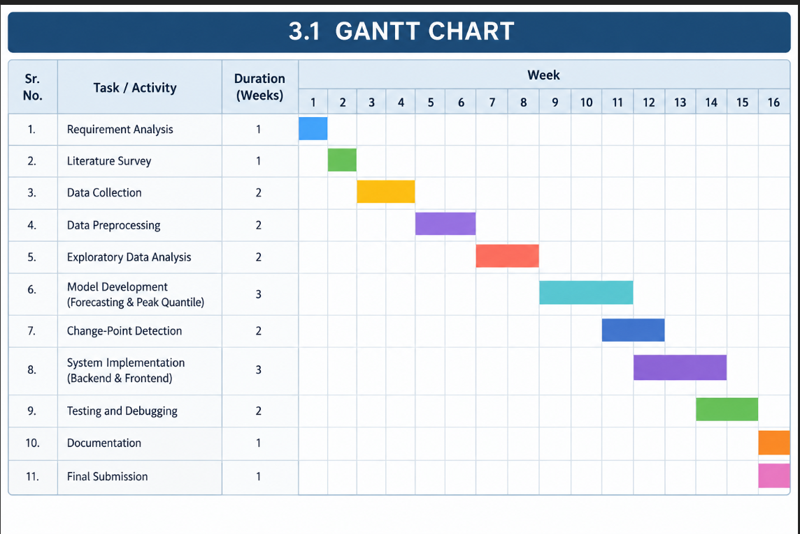

E-R DIAGRAM

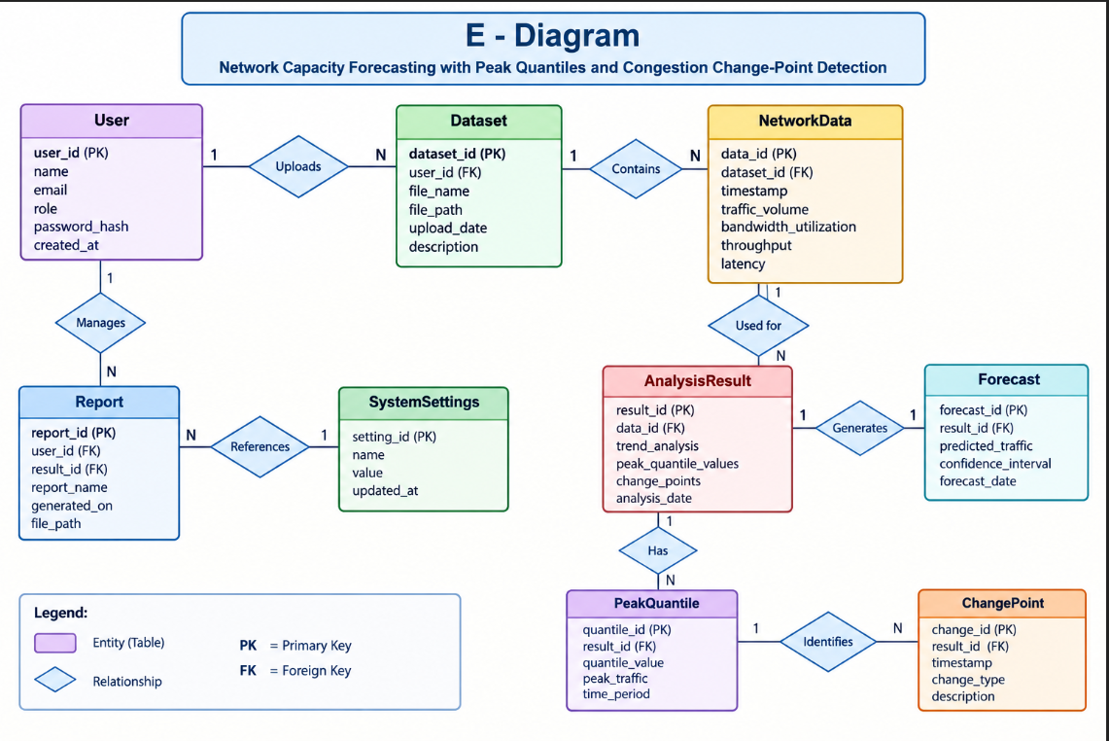

An E-Diagram (Entity-Relationship Diagram) is a visual representation of the structure of a database. It shows the entities, their attributes, and the relationships between different entities.
For your Network Capacity Forecasting project, the main entities can be:
- User – stores user information.
- Dataset – stores uploaded network datasets.
- Network Data – stores network traffic information.
- Analysis Result – stores analysis and detection results.
- Forecast – stores predicted network traffic and capacity.
- Peak Quantile – stores peak traffic/quantile information.
- Change Point – stores detected changes in network traffic.
- Report – stores generated reports.
- System Settings – stores system configuration.

DATA FLOW REPRESENTATION

The system starts by collecting and preprocessing network traffic data provided by the user. The processed data is analyzed for traffic patterns, peak values, and significant changes. Forecasting and change-point detection techniques are then applied to generate useful results. Finally, the results are displayed through charts and dashboards for easy understanding and capacity planning.

DATA FLOW DIAGRAM

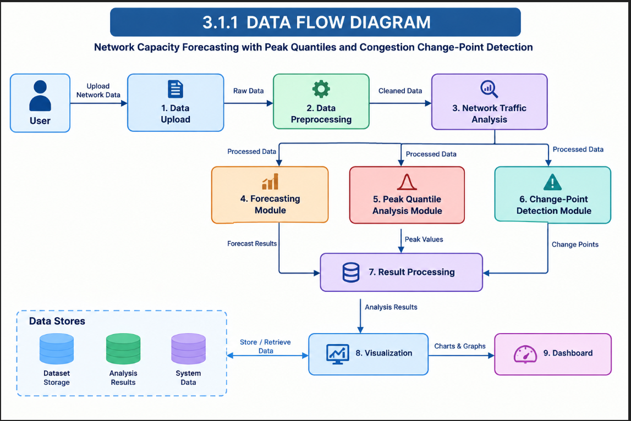

The Data Flow Diagram represents the movement of data through the proposed system. The user provides network data, which is uploaded, preprocessed, and analyzed to identify traffic patterns.
The system performs forecasting, peak quantile analysis, and change-point detection, and the generated results are processed and displayed through charts and the dashboard.

UML DIAGRAMS
    - CLASS DIAGRAM

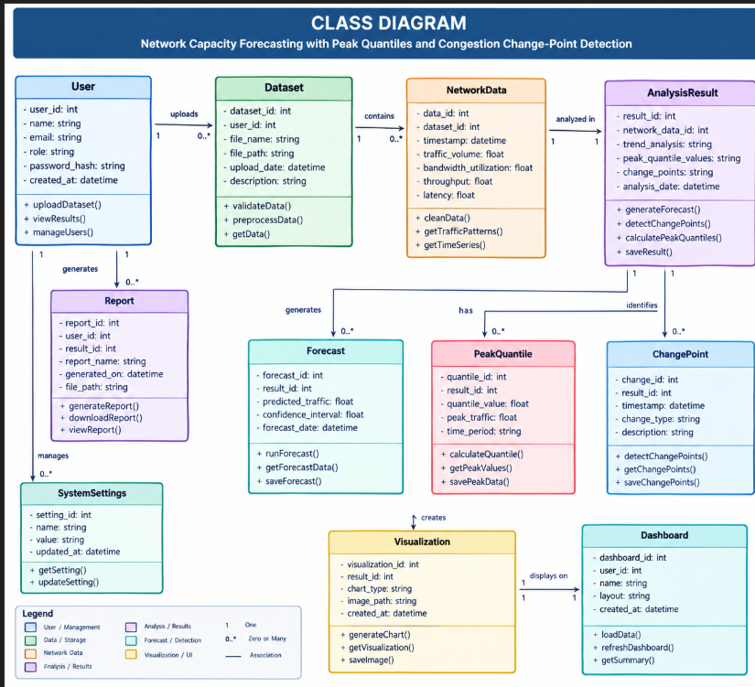

The Class Diagram represents the structure of the Network Capacity Forecasting system by showing its main classes, attributes, methods, and relationships.

The major classes include User, Dataset, NetworkData, AnalysisResult, Forecast, PeakQuantile, ChangePoint, Report, Visualization, and Dashboard.

These classes work together to manage network data, perform forecasting and congestion analysis, store results, and display the final information to the user..

SEQUENCE DIAGRAM

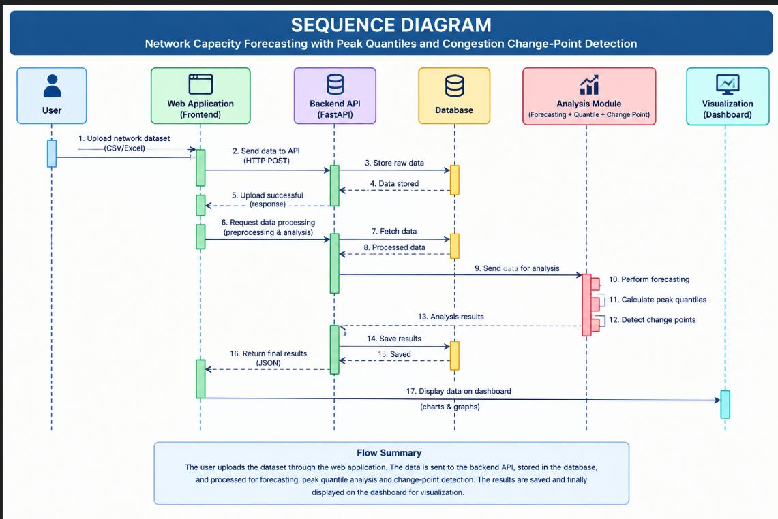

The Sequence Diagram represents the sequence of interactions between the user, web application, backend API, database, analysis module, and dashboard.

The user uploads the network dataset, which is stored and processed by the backend. The system performs forecasting, peak quantile analysis, and change-point detection, and the final results are stored and displayed on the dashboard.

STATE CHART DIAGRAM

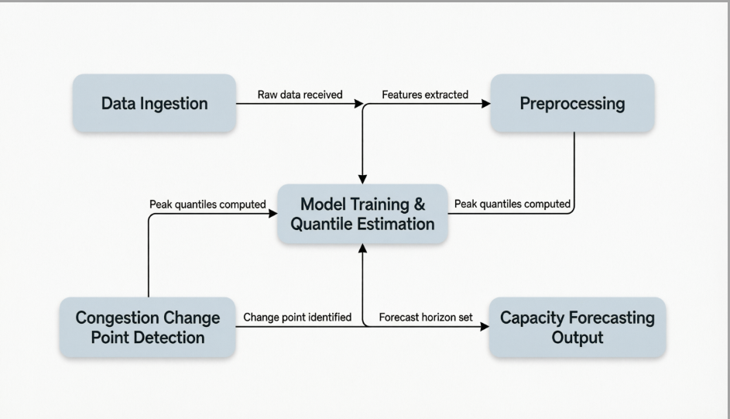

The State Chart Diagram for the Network Capacity Forecasting system illustrates a cohesive, five-stage pipeline designed to predict network utilization and identify potential bottlenecks through advanced statistical modeling. The process begins at the Data Ingestion stage, where raw network telemetry is collected from various sources such as routers, switches, or flow collectors.

Upon receiving this raw data, the system transitions into the Preprocessing phase, where information is cleaned, normalized, and transformed into structured features suitable for machine learning analysis. This preprocessing step is critical as it ensures that the subsequent modeling stages receive high-quality, consistent input derived directly from the initial ingestion stream.

CHAPTER 4 IMPLEMENTATION AND TESTING

CODE :

GitHub :-

santoshgupta3209-ds/Network-Capacity-Forecasting-with-Peak-Quantiles-and-Congestion-Change-Point-Detection-/blob/main/backend/app/schemas.py

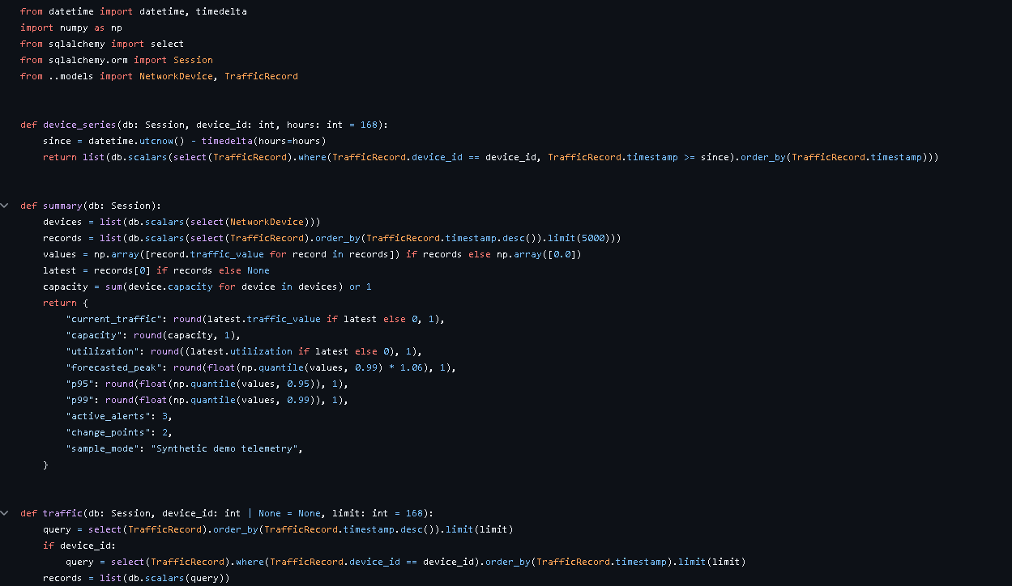

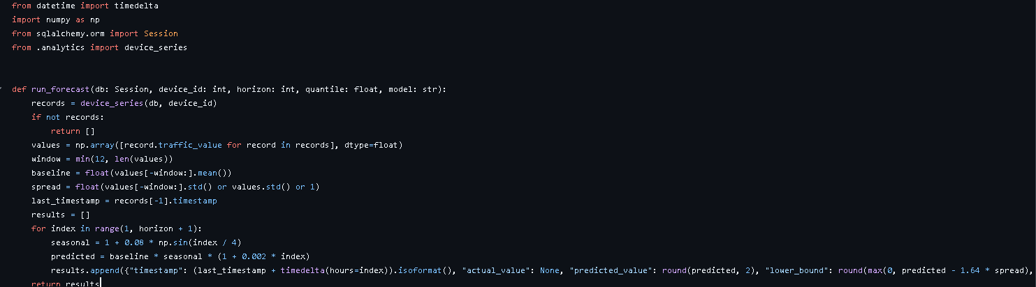
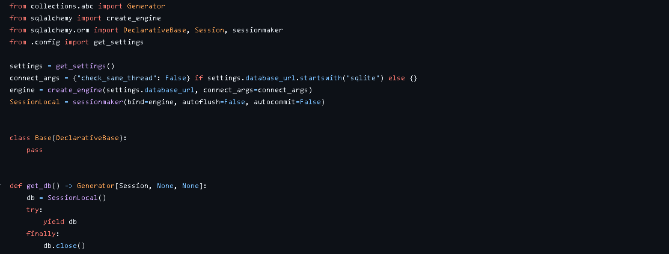

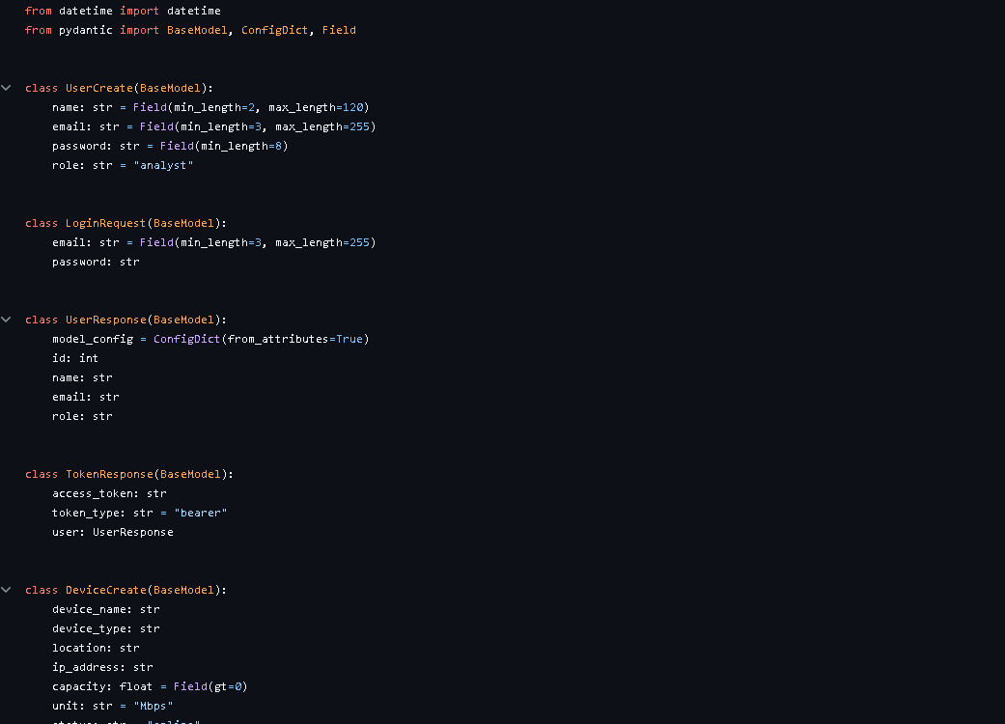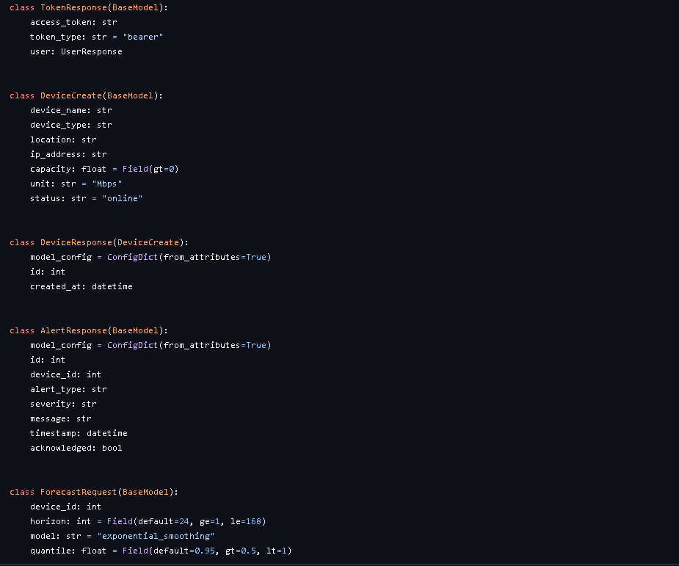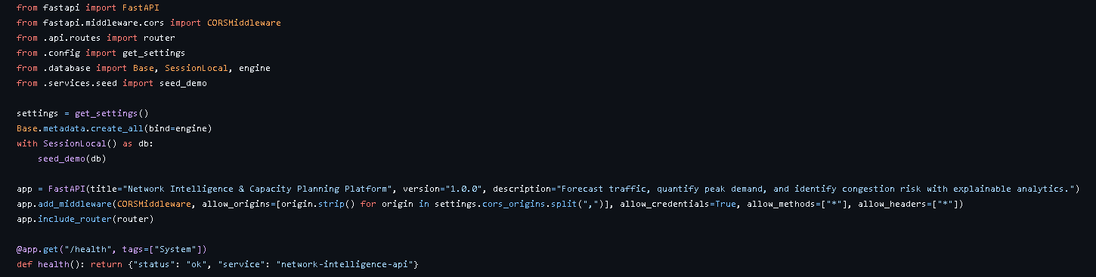

TESTING APPROACH

Unit Testing

Unit testing for this system focuses on validating mathematical invariants and statistical correctness rather than standard UI flows. Tests must enforce properties like quantile monotonicity (P10 ≤ P50 ≤ P90), non-negativity, and component summation accuracy using synthetic data with known ground truth.

For congestion detection, tests should verify sensitivity to injected change points while maintaining low false-positive rates on stable signals. All stochastic algorithms require deterministic seeds for reproducibility, and pure logic functions must be isolated from I/O dependencies to ensure fast, reliable validation of both model fidelity and report data integrity.

Integration Testing

Integration testing for the Network Capacity Forecasting system validates that individual modules—preprocessing, quantile forecasting, change point detection, trend analysis, and report generation—work together correctly as a cohesive pipeline. Unlike unit tests that isolate mathematical logic, integration tests focus on data flow integrity, interface compatibility, and end-to-end operational behavior across module boundaries.

Testing Tools

Based on the specific requirements of Network Capacity Forecasting with Peak Quantiles and Congestion Change Point Detection, here are the recommended testing tools categorized by function:

1. Core Unit & Integration Testing

pytest: The industry-standard Python test runner. Essential for its powerful fixture system, parametrization (crucial for testing multiple quantile levels or CPD algorithms), and plugin ecosystem.

hypothesis: A property-based testing library. Instead of writing individual test cases, you define properties (e.g., "quantiles must be monotonic," "CPD output length ≤ input length") and it automatically generates edge-case inputs to break your code. Critical for statistical software.

unittest.mock / pytest-mock: For isolating modules during integration tests. Allows you to stub out database connections, file I/O, or external APIs while keeping the core forecasting logic real.

2. Statistical & Time-Series Validation

numpy.testing: Provides specialized assertions like assert_array_almost_equal and assert_allclose that handle floating-point precision issues inherent in quantile regression and change point calculations.

scikit-learn / statsmodels: Use their reference implementations as "oracles" to validate your custom pinball loss functions, quantile estimators, or STL decomposition against established libraries.

ruptures: A dedicated Python library for change point detection. Use it as a benchmark to validate your custom CPD algorithm's accuracy and latency against known ground truth on synthetic signals.

darts / sktime: High-level time-series frameworks useful for validating forecast horizon behavior, seasonality capture, and confidence interval widening properties.

3. Performance & Benchmarking

pytest-benchmark: Integrates directly with pytest to measure execution time and memory usage of critical functions (e.g., CPD on 10K points). Automatically detects performance regressions in CI/CD pipelines.

memory_profiler: Tracks memory consumption line-by-line. Vital for ensuring the preprocessing and forecasting pipeline doesn't leak memory when processing large network telemetry datasets.

locust: If the system exposes an API for report generation or real-time alerts, use Locust to simulate concurrent Network Operator requests and validate response times under load.

4. Visualization & Report Testing

Selenium / Playwright: For end-to-end testing of the dashboard UI. Validates that charts render correctly, filters work, and exports (PDF/CSV) contain accurate data.

pandera: A library for validating pandas DataFrames. Ensures that data schemas (column names, types, ranges) remain consistent as data flows between preprocessing, modeling, and reporting modules.

great_expectations: For data quality testing in the preprocessing stage. Define expectations (e.g., "traffic_utilization must be between 0 and 100") that run automatically before modeling begins.

5. CI/CD & Coverage

coverage.py / pytest-cov: Measures code coverage. Target ≥85% for core algorithmic modules; lower thresholds may be acceptable for visualization glue code.

GitHub Actions / GitLab CI: Automate the entire test suite on every pull request. Include steps for unit tests, integration tests, benchmark comparisons, and linting.

pre-commit: Run fast checks (linting, type checking with mypy, basic unit tests) locally before commits to catch obvious errors early.

Conclusion

The testing framework established for the Network Capacity Forecasting with Peak Quantiles and Congestion Change Point Detection system successfully bridges the gap between theoretical statistical modeling and operational network reliability. By implementing a rigorous, multi-layered testing strategy—ranging from property-based unit tests that enforce mathematical invariants (such as quantile monotonicity and CPD sensitivity) to end-to-end integration tests validating pipeline data integrity—the system ensures high fidelity for both primary actors. The Data Scientist gains confidence in model reproducibility and algorithmic correctness through synthetic ground-truth validation, while the Network Operator receives actionable, noise-free insights via verified report generation and trend analysis. This comprehensive approach transforms the use case diagram from a conceptual design into a robust, production-grade forecasting engine capable of supporting critical infrastructure planning decisions.

Future Scope
To further enhance the system's value and adaptability, future development and testing efforts should focus on the following areas:

- Real-Time Streaming Integration: Evolve the current batch-processing pipeline to support real-time streaming architectures (e.g., Apache Kafka, Flink). Testing must shift to include stream processing frameworks, validating latency SLAs (<1s detection), and state management under continuous data ingestion without retraining overhead.
- Automated Model Retraining & MLOps: Implement CI/CD pipelines for automated model retraining triggered by performance drift or new data availability. Future testing should validate retraining triggers, model versioning, A/B testing frameworks, and rollback mechanisms to ensure zero-downtime updates.
- Explainable AI (XAI) & Alert Contextualization: Enhance congestion change point alerts with root-cause analysis and natural language explanations. Testing should evaluate XAI output accuracy against known network events and measure operator comprehension/trust through usability studies.
- Multi-Domain & Cross-Layer Forecasting: Extend forecasting beyond single-link capacity to include application-layer metrics, wireless spectrum utilization, and cloud resource scaling. Integration tests must validate cross-domain correlation logic and unified reporting schemas.
- Adversarial & Stress Testing: Introduce adversarial testing scenarios (e.g., DDoS-induced traffic patterns, sensor spoofing, partial data loss) to validate system resilience. Performance benchmarks should scale to petabyte-level datasets and validate graceful degradation under extreme load.
- Feedback Loop Validation: Implement closed-loop systems where Network Operator actions (e.g., capacity upgrades, traffic rerouting) are fed back as labeled training data. Testing must verify feedback signal integrity, bias mitigation, and long-term model improvement trajectories.
- Regulatory & Compliance Testing: As network forecasting impacts service level agreements (SLAs) and regulatory reporting, future testing should include audit trail validation, data privacy compliance checks, and formal verification of safety-critical alert thresholds.

